Calculus 2 Lecture 9.2: Series, Geometric Series, Harmonic Series, and Divergence Test

A series is like a sequence except a math operation is applied to each term.
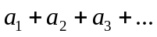
Written as 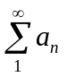
Or
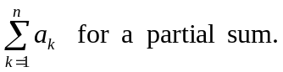

For the next “n” the is a new “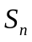”. This creates a sequence of partial sums.

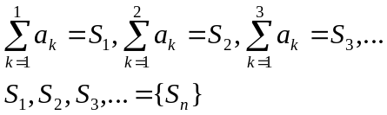

NOTE:
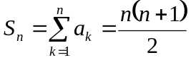 formula for a partial sum to the nth term

NOTE:
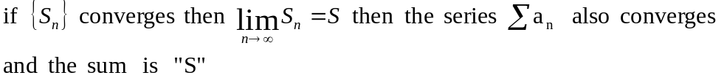

NOTE
Partial sum formula for the nth term
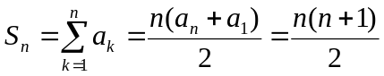

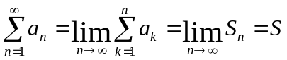 if converges
no sum

Example
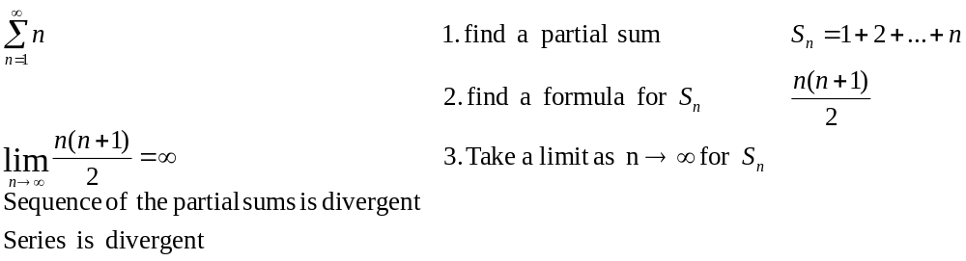
Example
i.e. Telescoping series
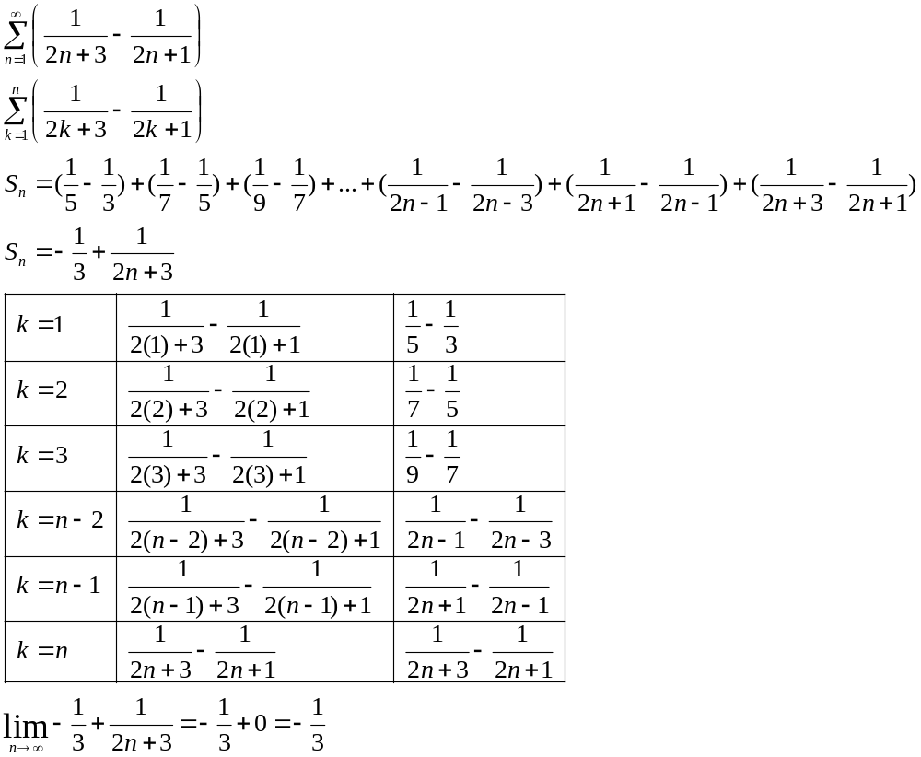

Example
i.e. Telescoping series
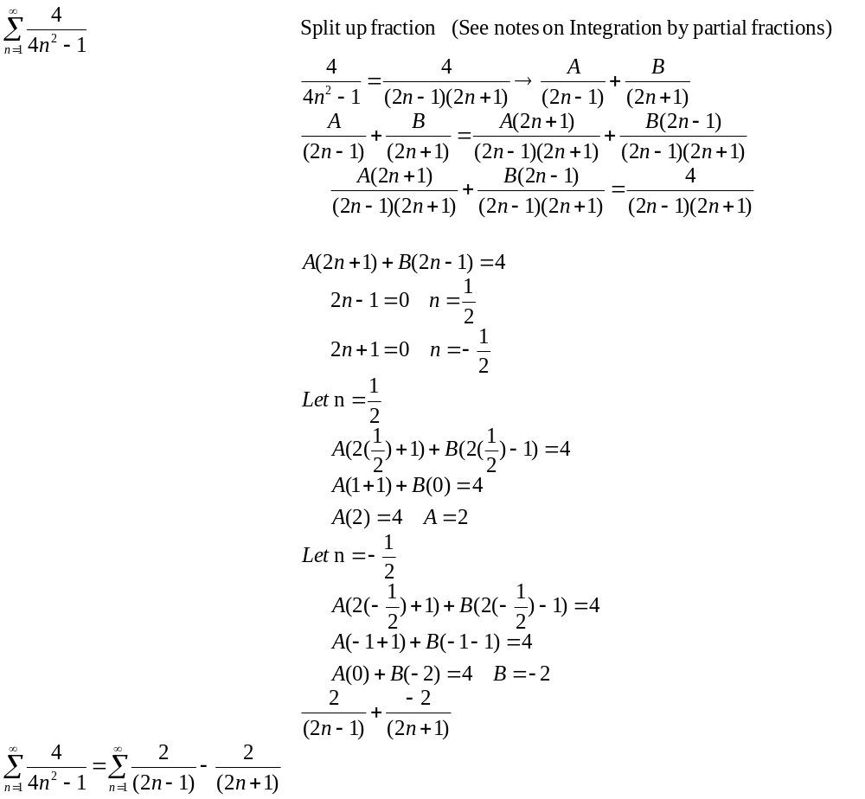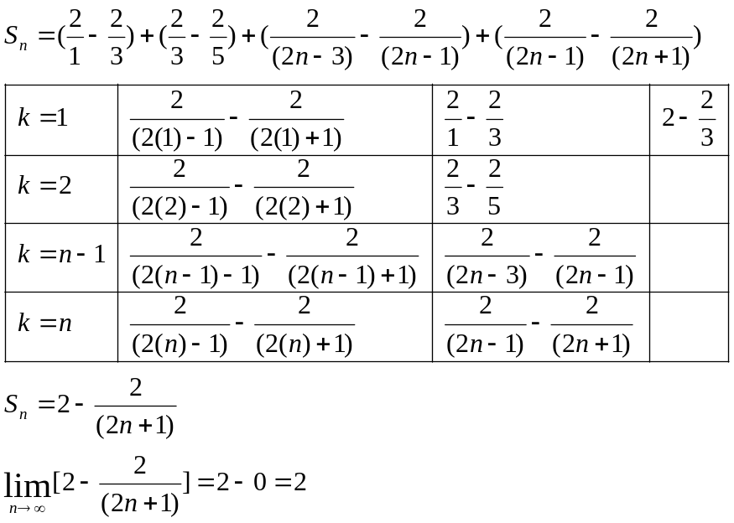
Geometric Series
A geometric series is defined to be
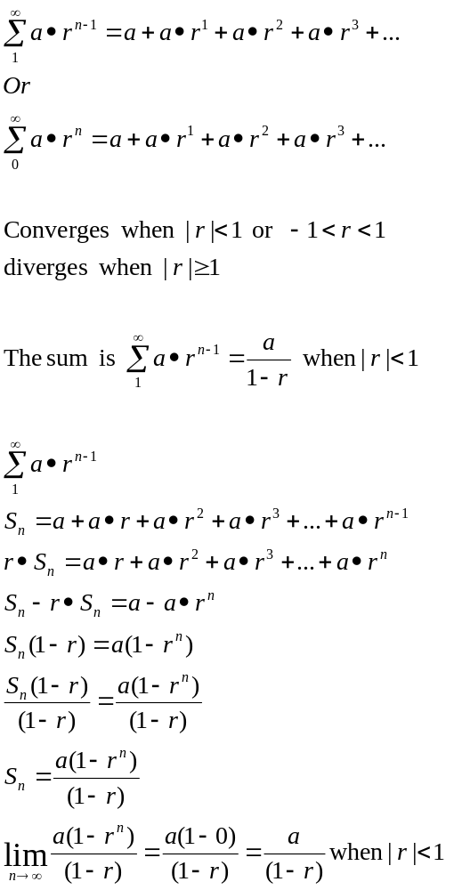
Example
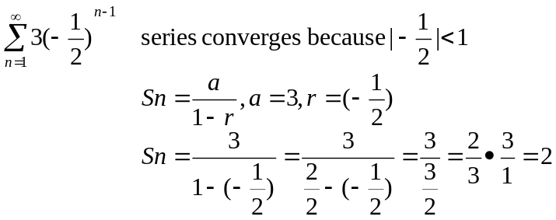
Example
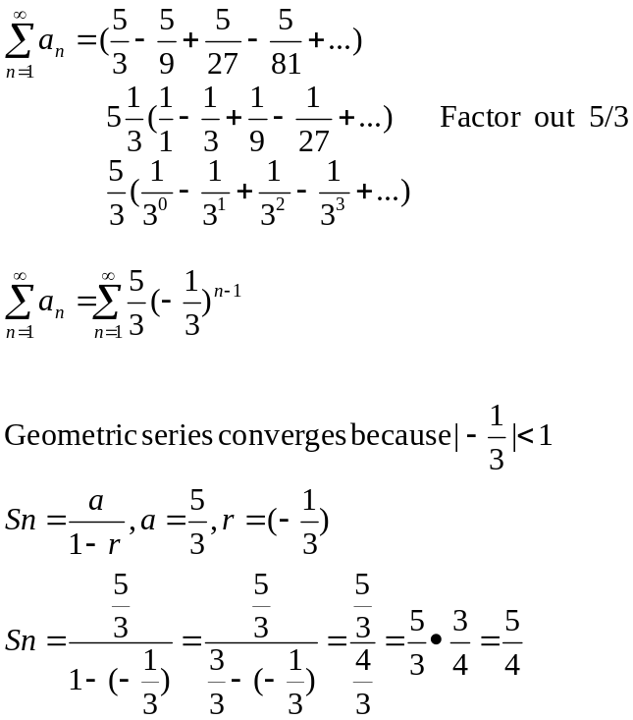

Example
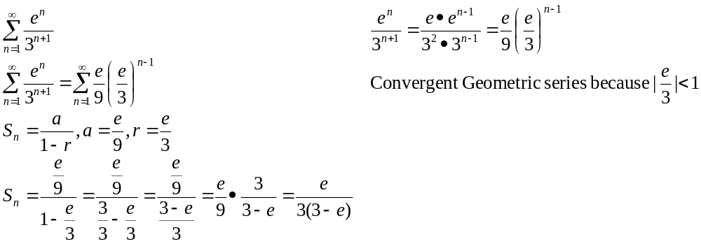

Harmonic Series
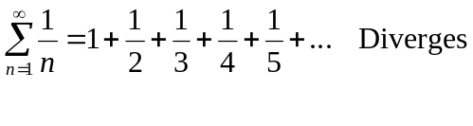
NOTES: (Divergence Test)
If a sequence 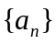 Convergent any subsequence of must also be convergent.
To show diverges, then it is enough to show that a subsequence diverges

If a series 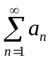 converges,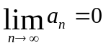 adding zero as the last term in order for the series to
converge.(What is the only number that I can add to my sum without the sum increasing? The number is zero.)
So, to show that a series diverges, It is enough to show 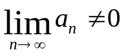

If or or does not exist then the series diverges.

** DOES NOT NECESSARY MEAN the series converges. It might but the limit is not a Proof of convergence

Example
Divergence test
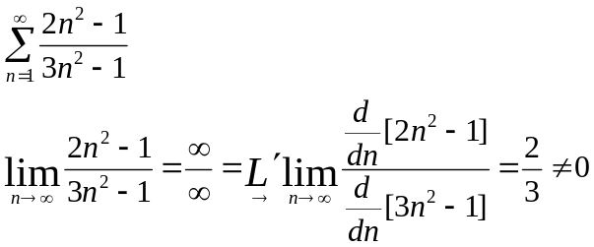
Diverges

Properties of convergent series
- 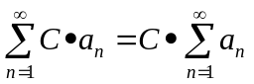
- 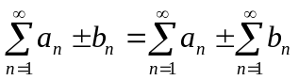

Example
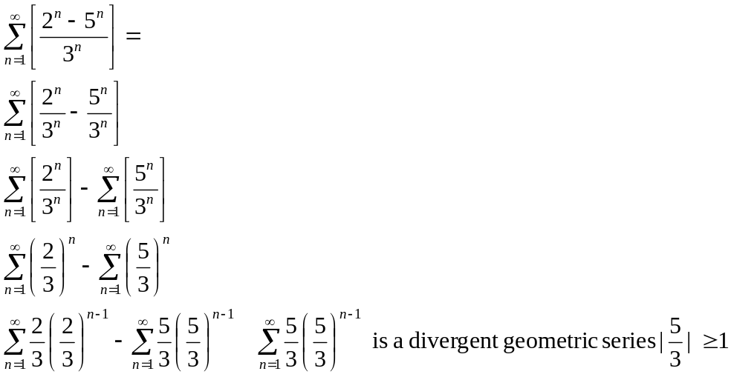

Example
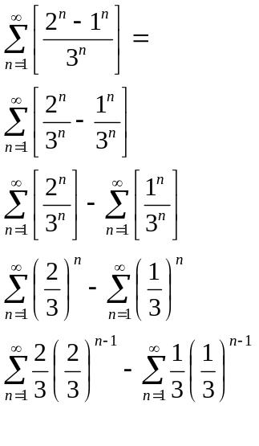

Example
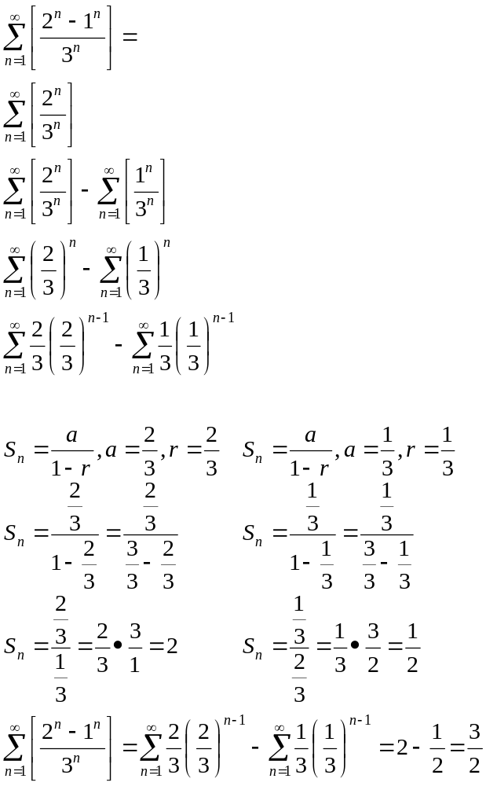

NOTE
